**Lab2-s3**

Create RHEL 8 ec2 instance

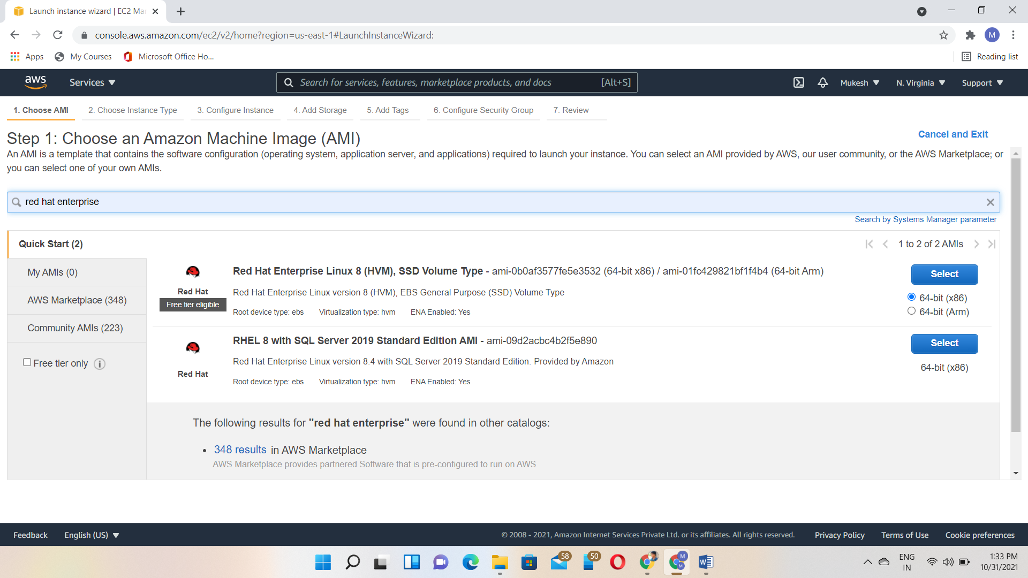

Instance created

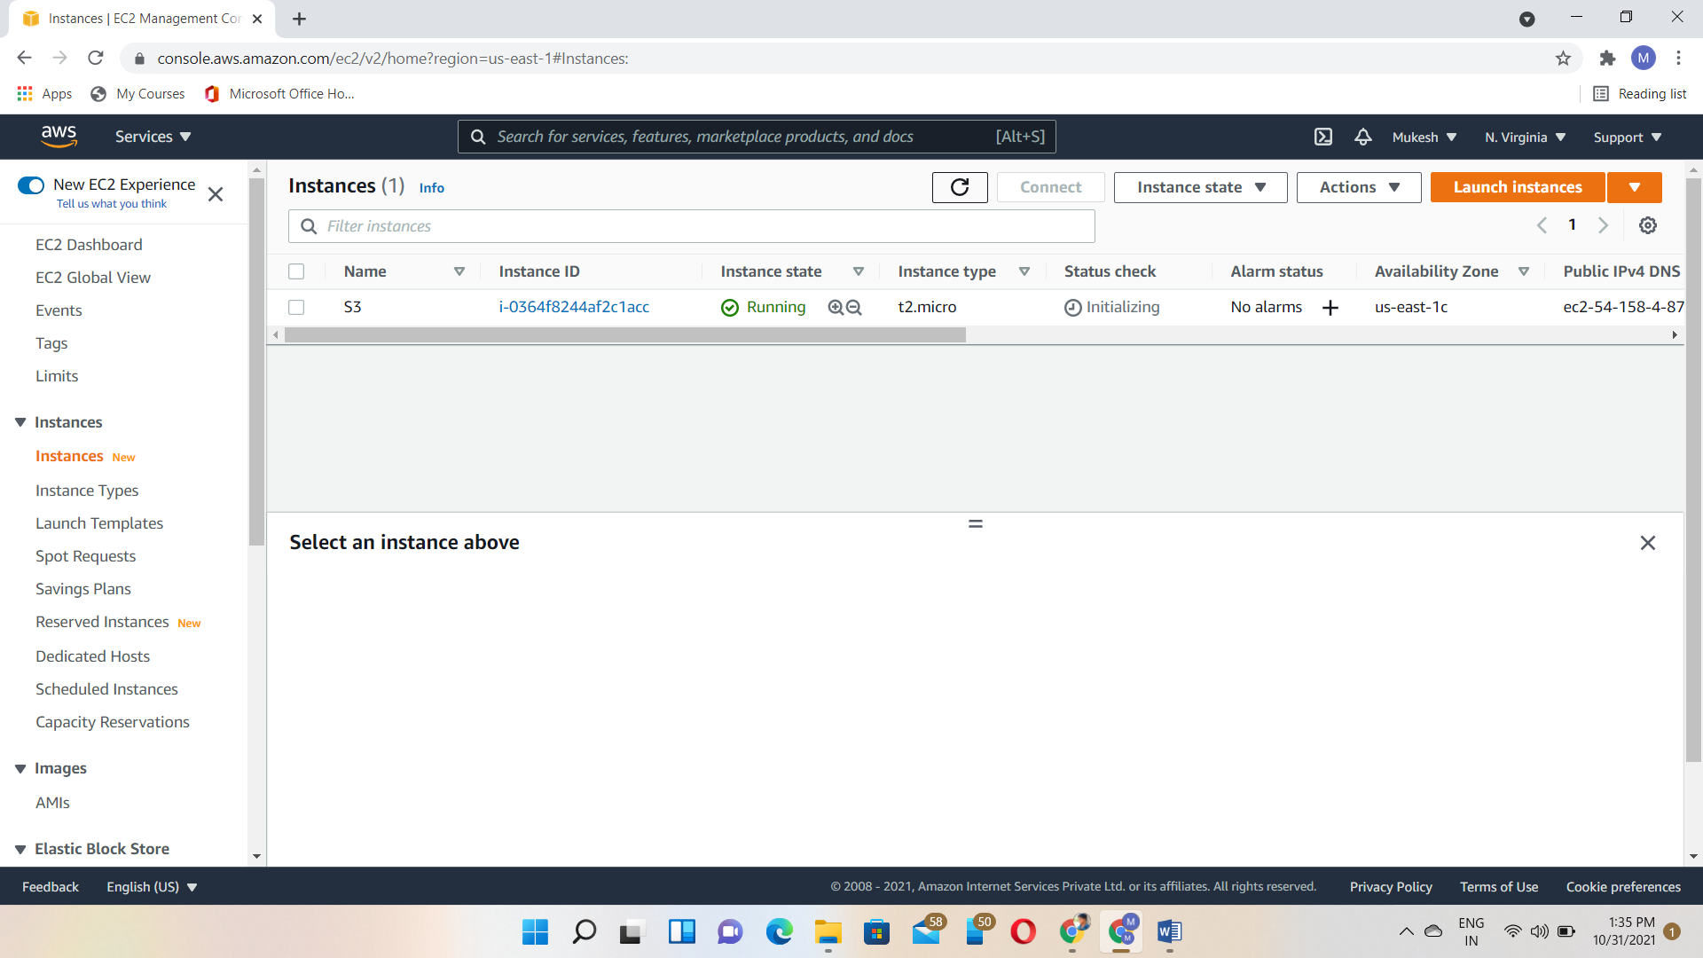

Login to the instance via putty

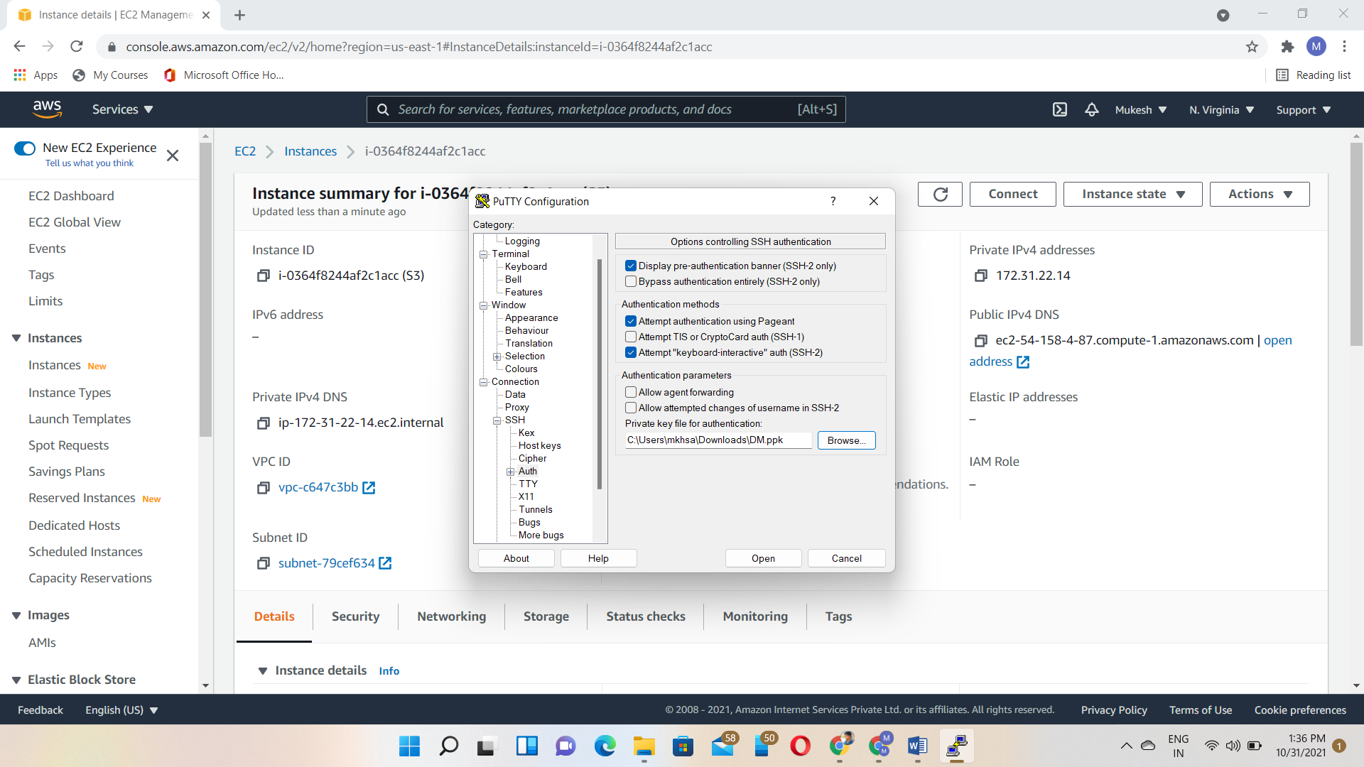

Getenforce-check the service status

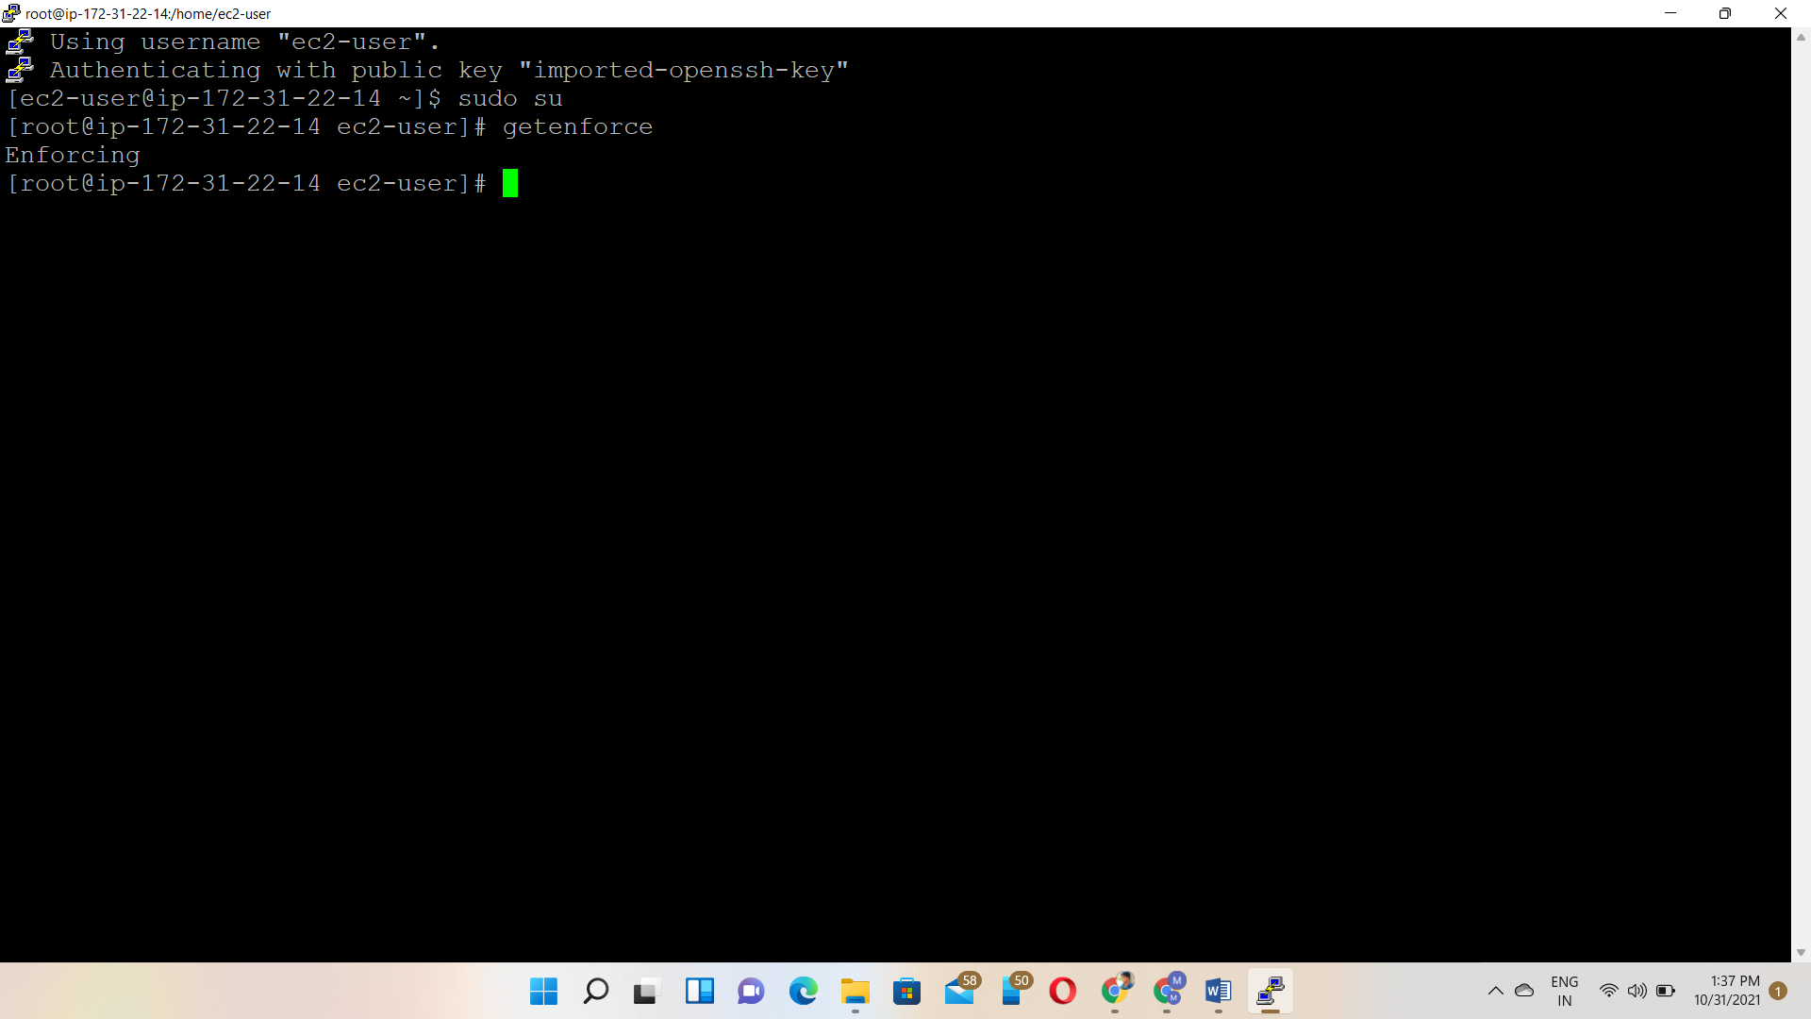

Install vim 🡪yum install vim -y

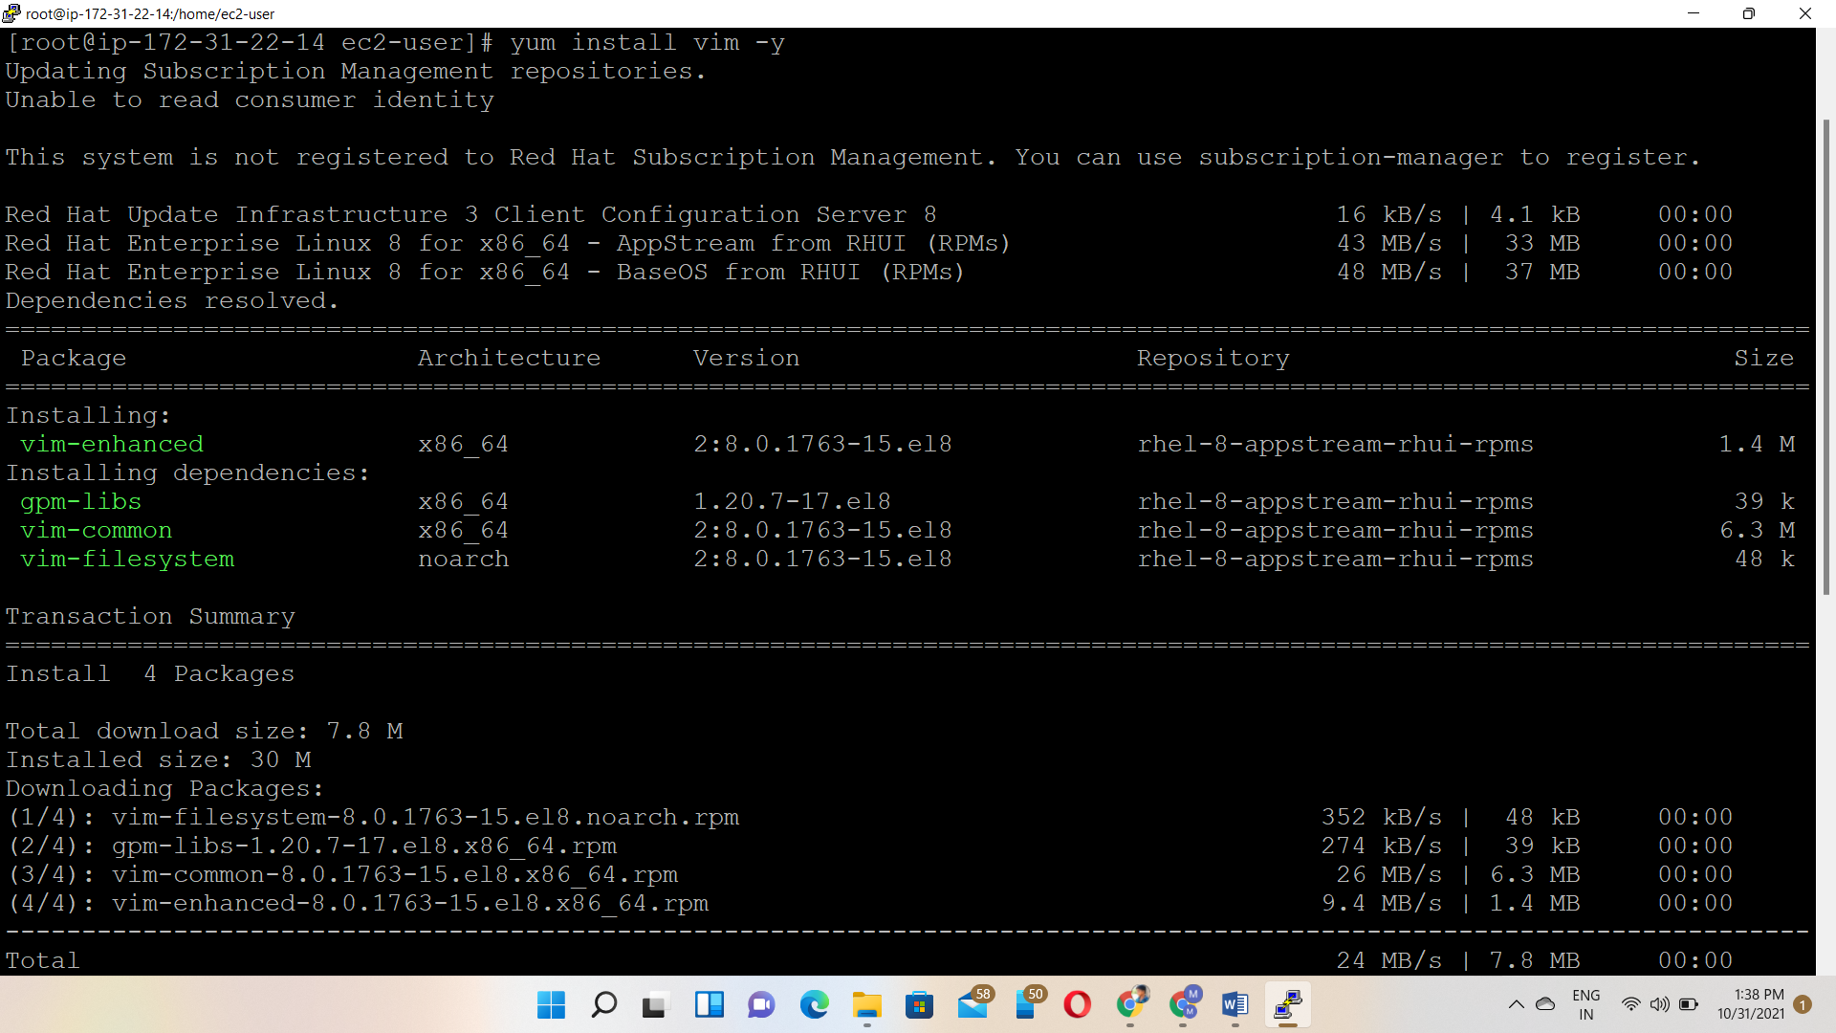

Disable the selinux

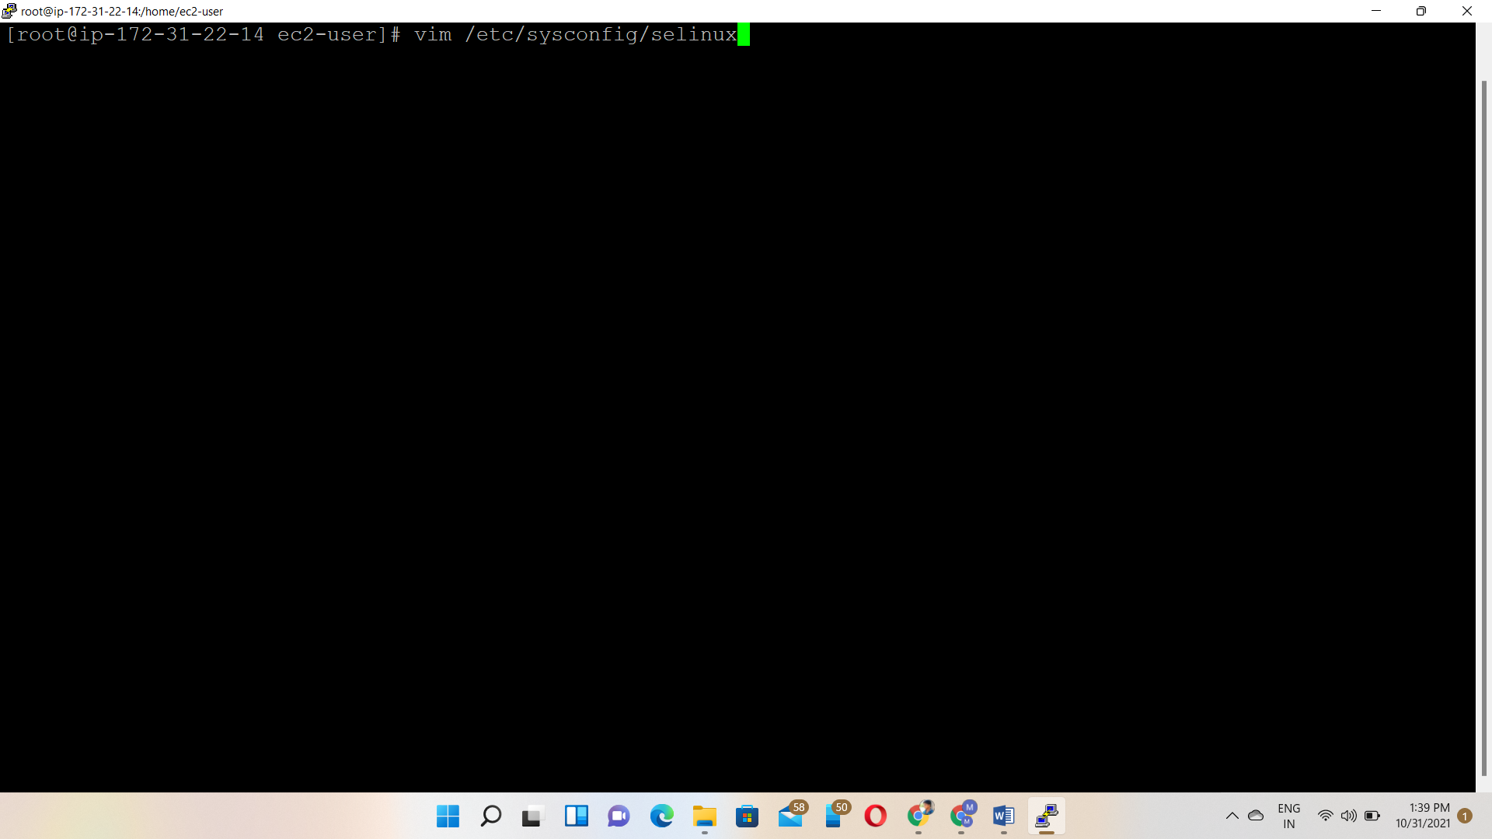

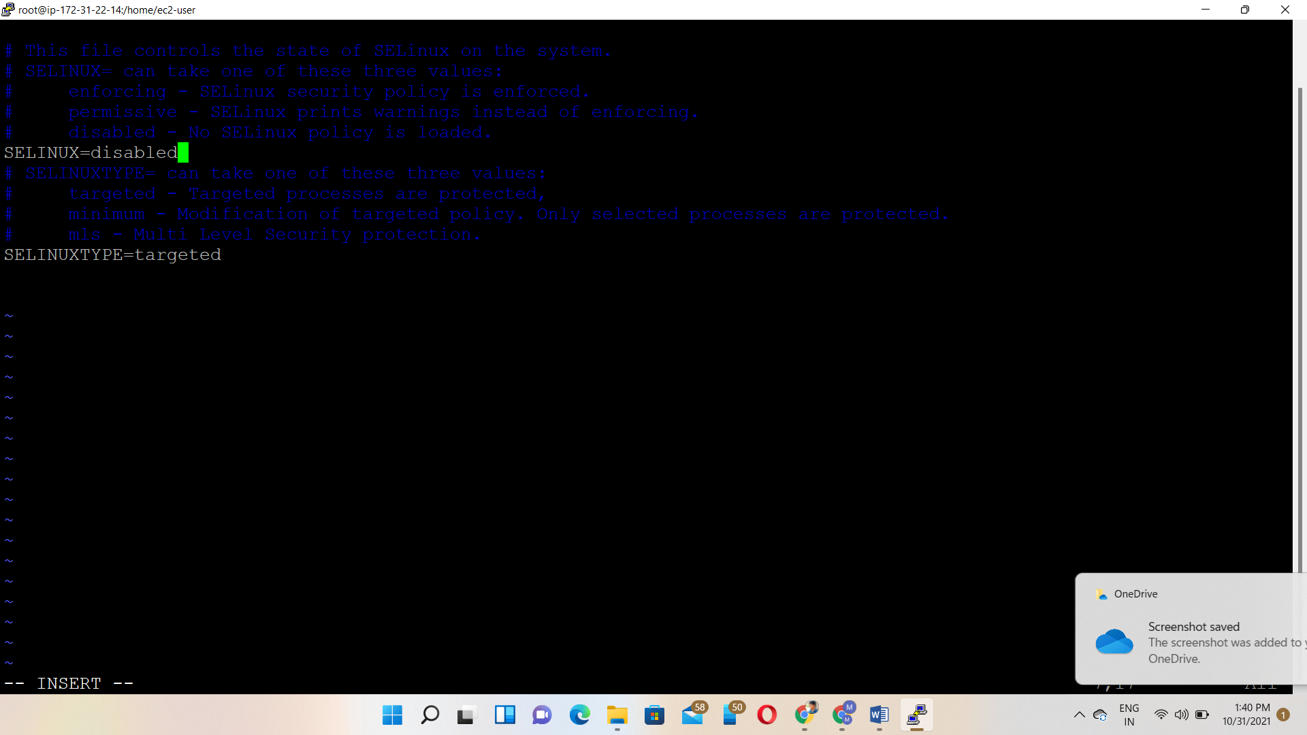

Once disable the selinux then reboot the instance

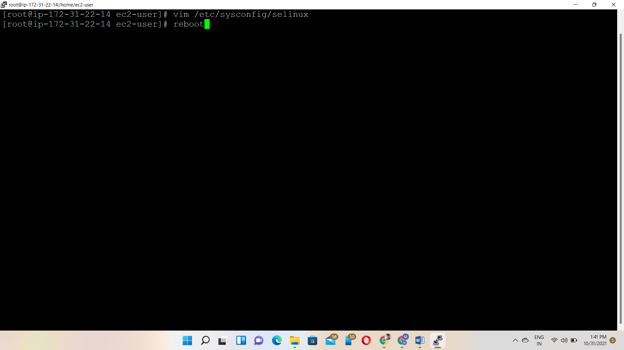

Again, check the service is disabled or not 🡪getenforce

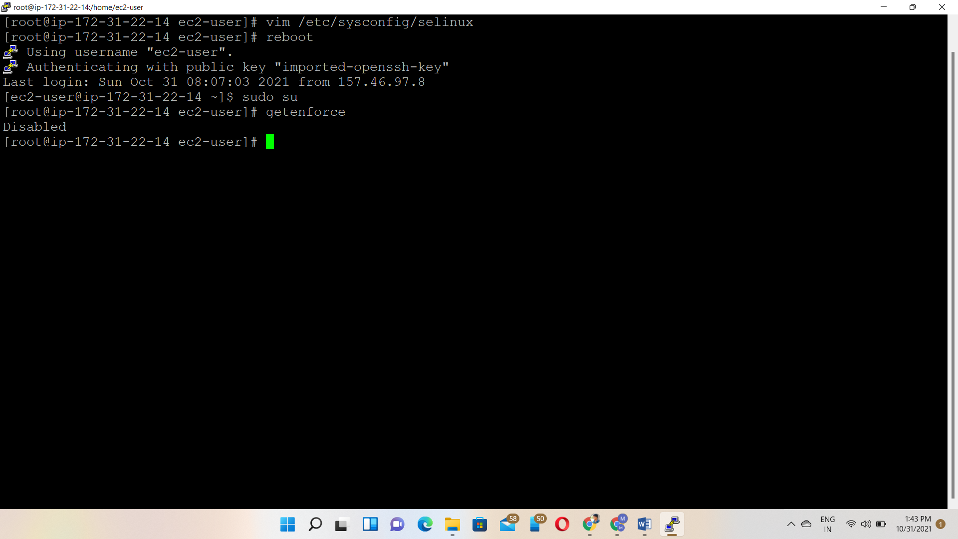

yum remove fuse fuse-s3fs 🡪 s3fs is a fuse file system that allows you to mount an Amazon S3 bucket as a local file system

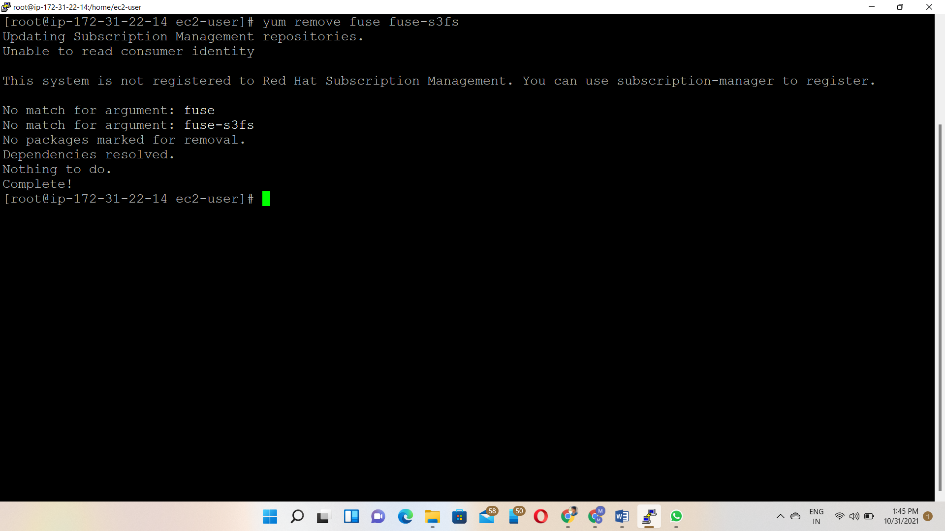

yum clean all - To clean all the files

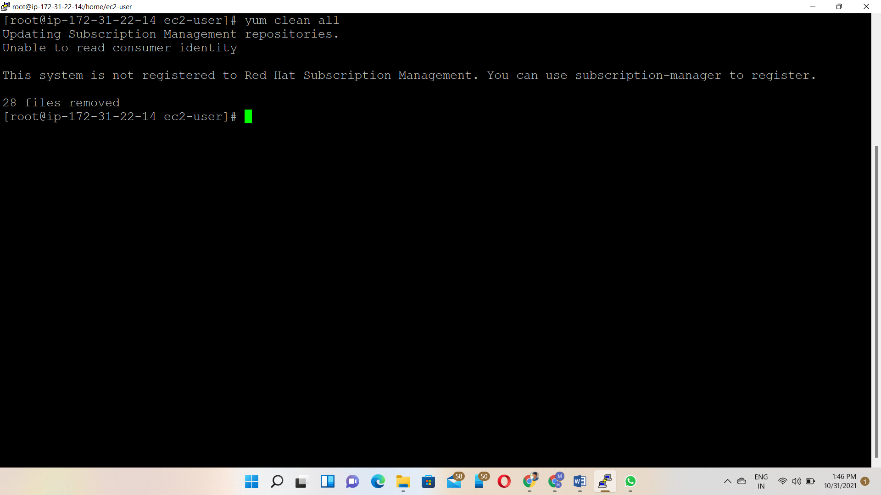

Install the s3fs-fuse service and type Y to install the packages - yum install gcc gcc-c++ openssl-devel libstdc++-devel libxml2-devel mailcap fuse fuse-devel fuse-libs

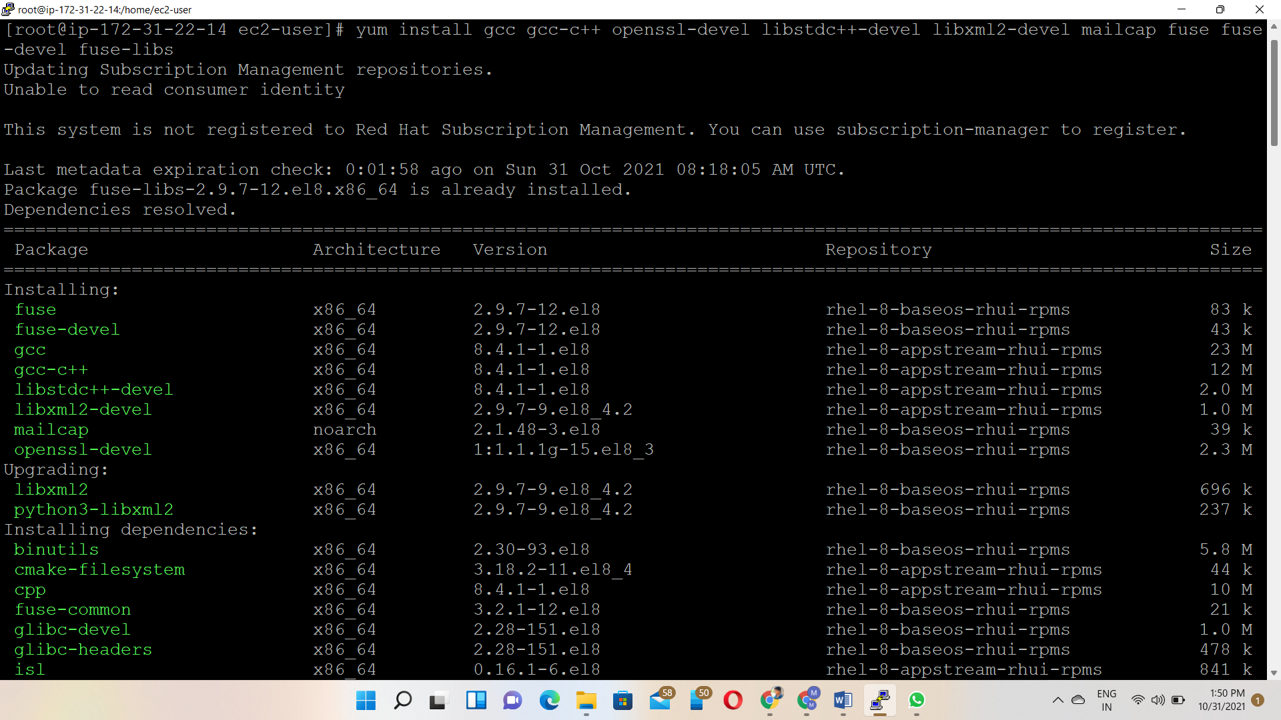

Install epel package🡪yum install https://dl.fedoraproject.org/pub/epel/epel-release-latest-8.noarch.rpm

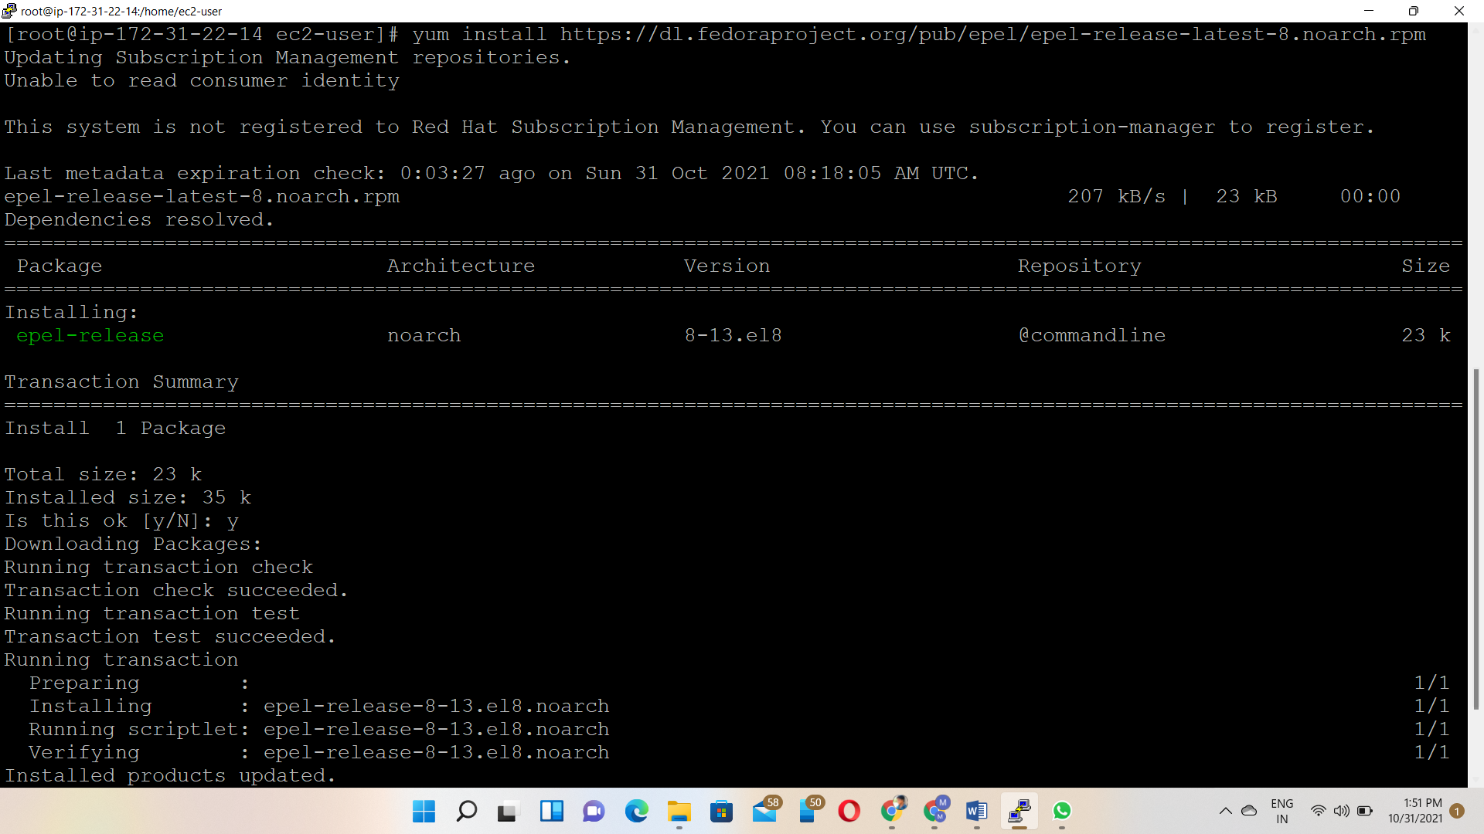

After epel installed🡪use this command 🡪sed -i 's/$releasever/8/g' /etc/yum.repos.d/epel*.repo and yum upgrade

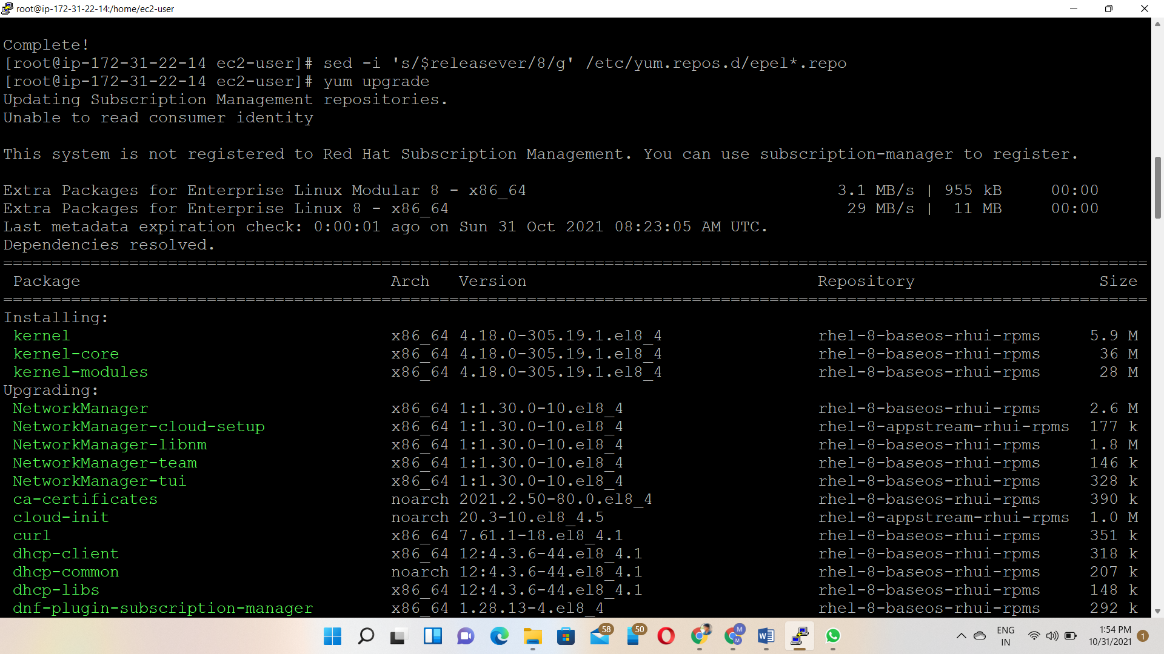

Now install missing s3fs-fuse package

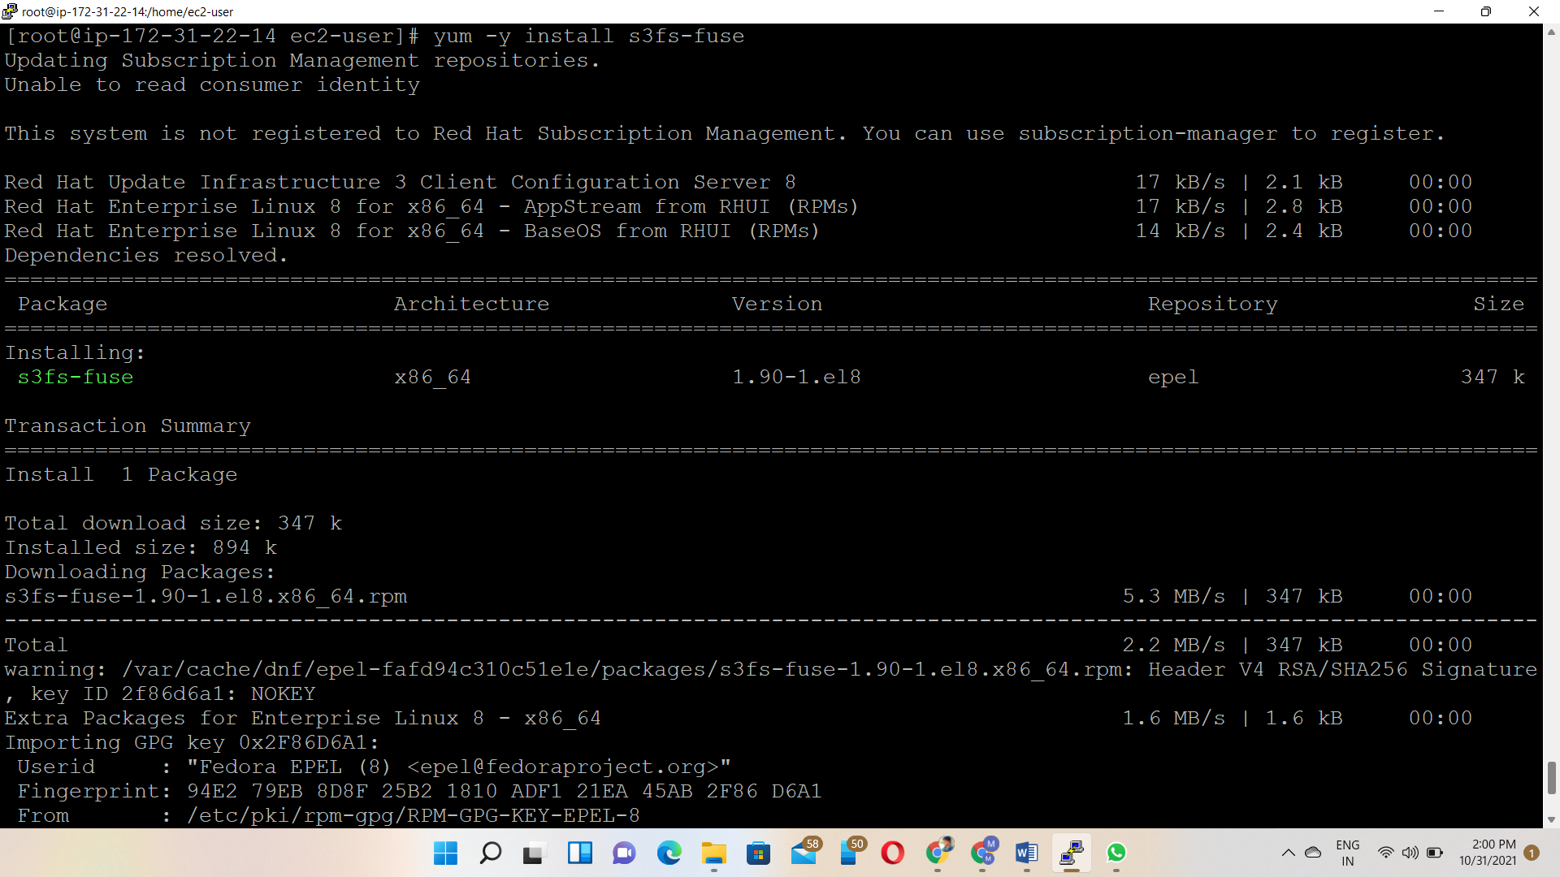

After s3fs package installed. To check the s3fs access

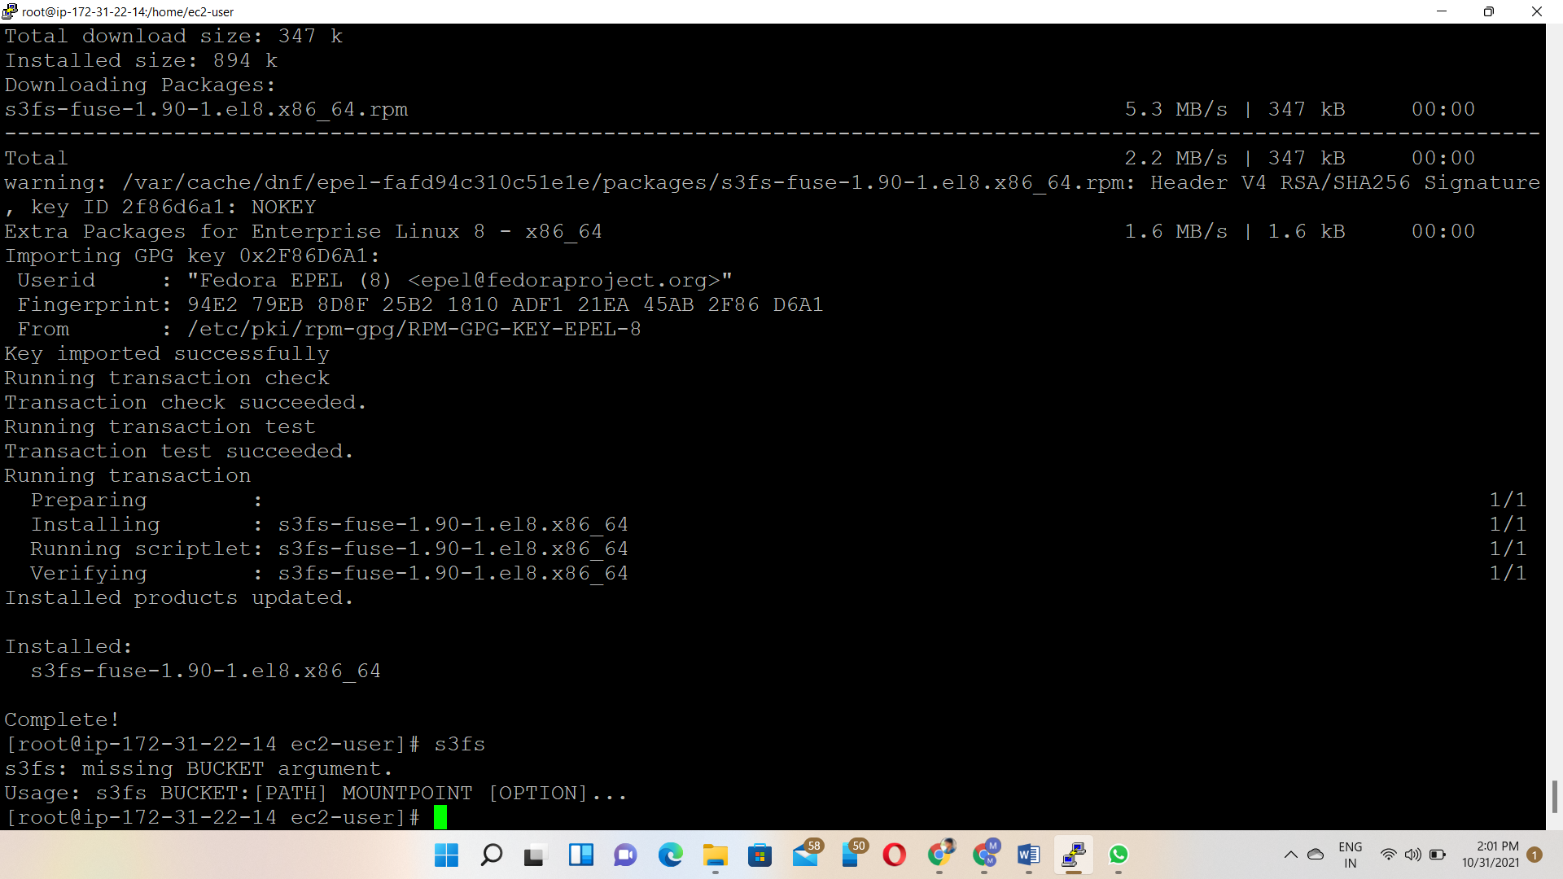

Go to IAM dashboard

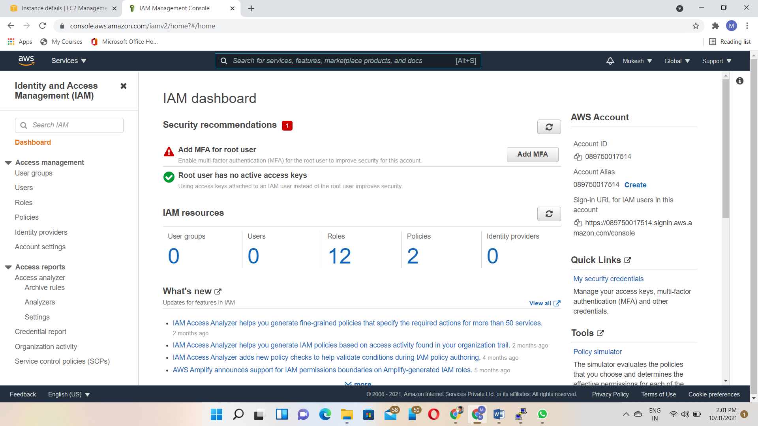

Create Add users in IAM and Select programmatic access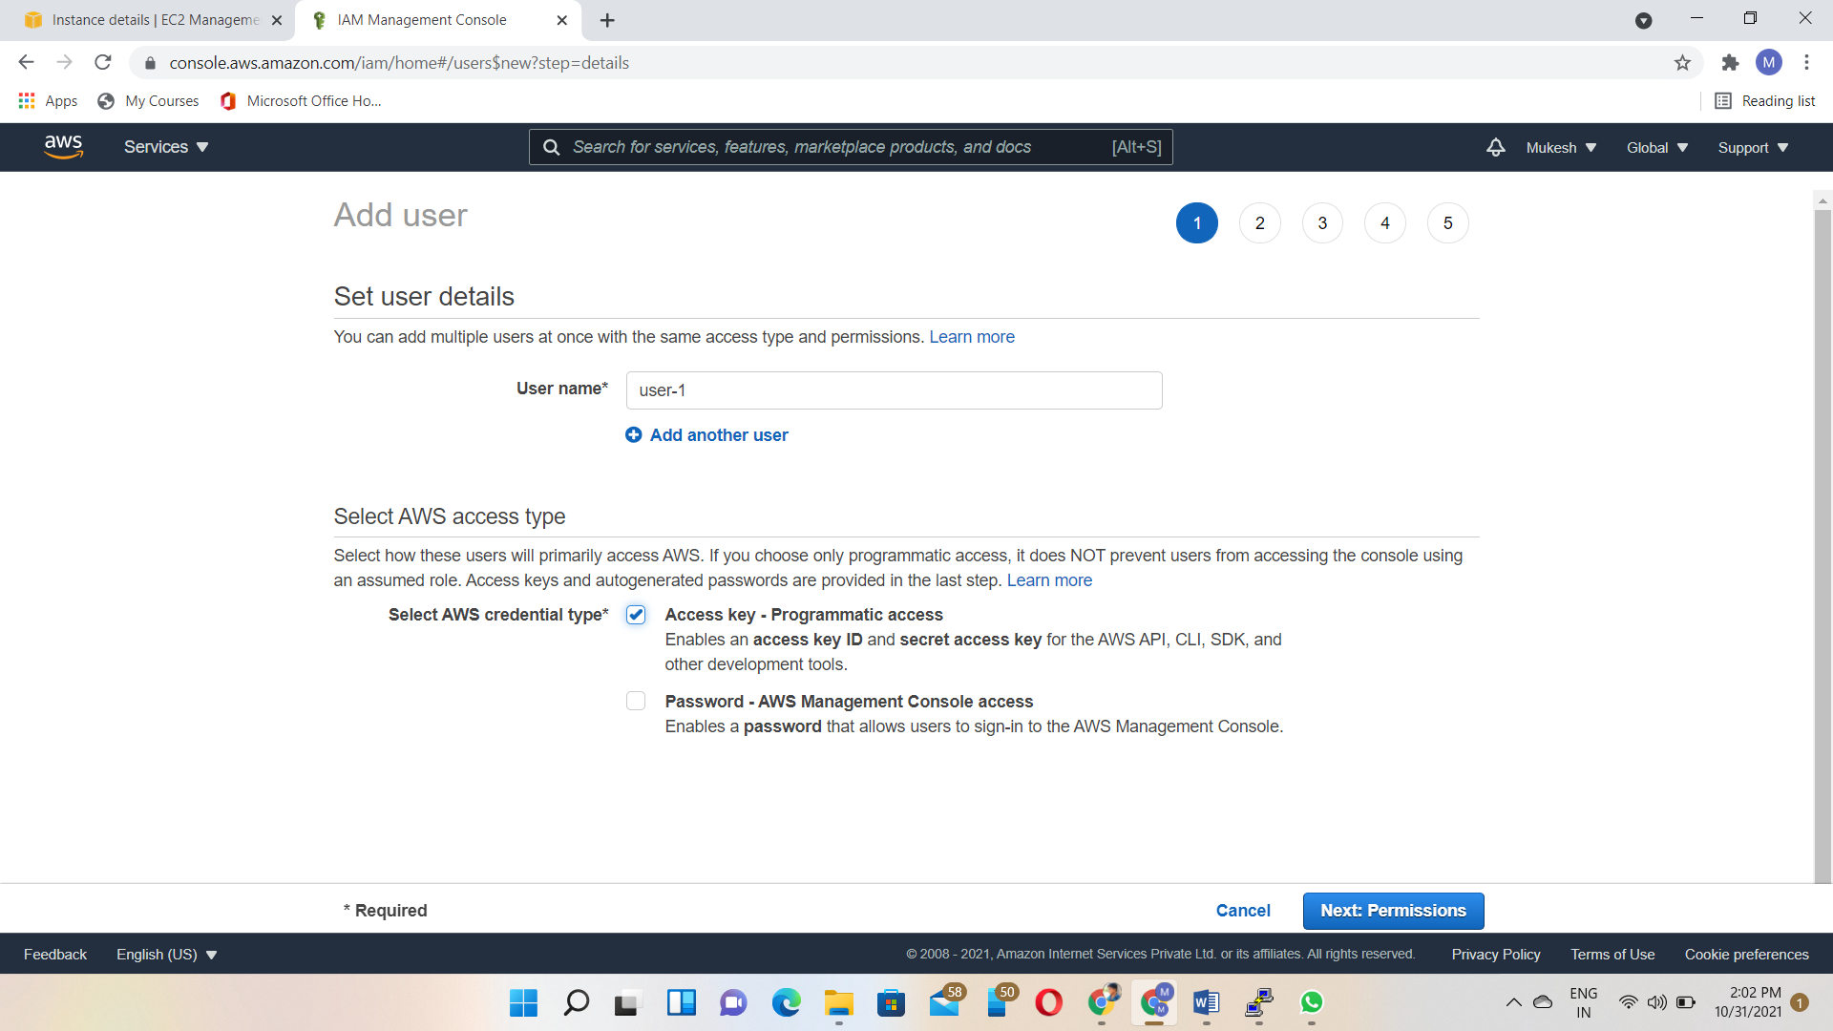

Select Attach existing policies directly and give AmazonS3FullAccess

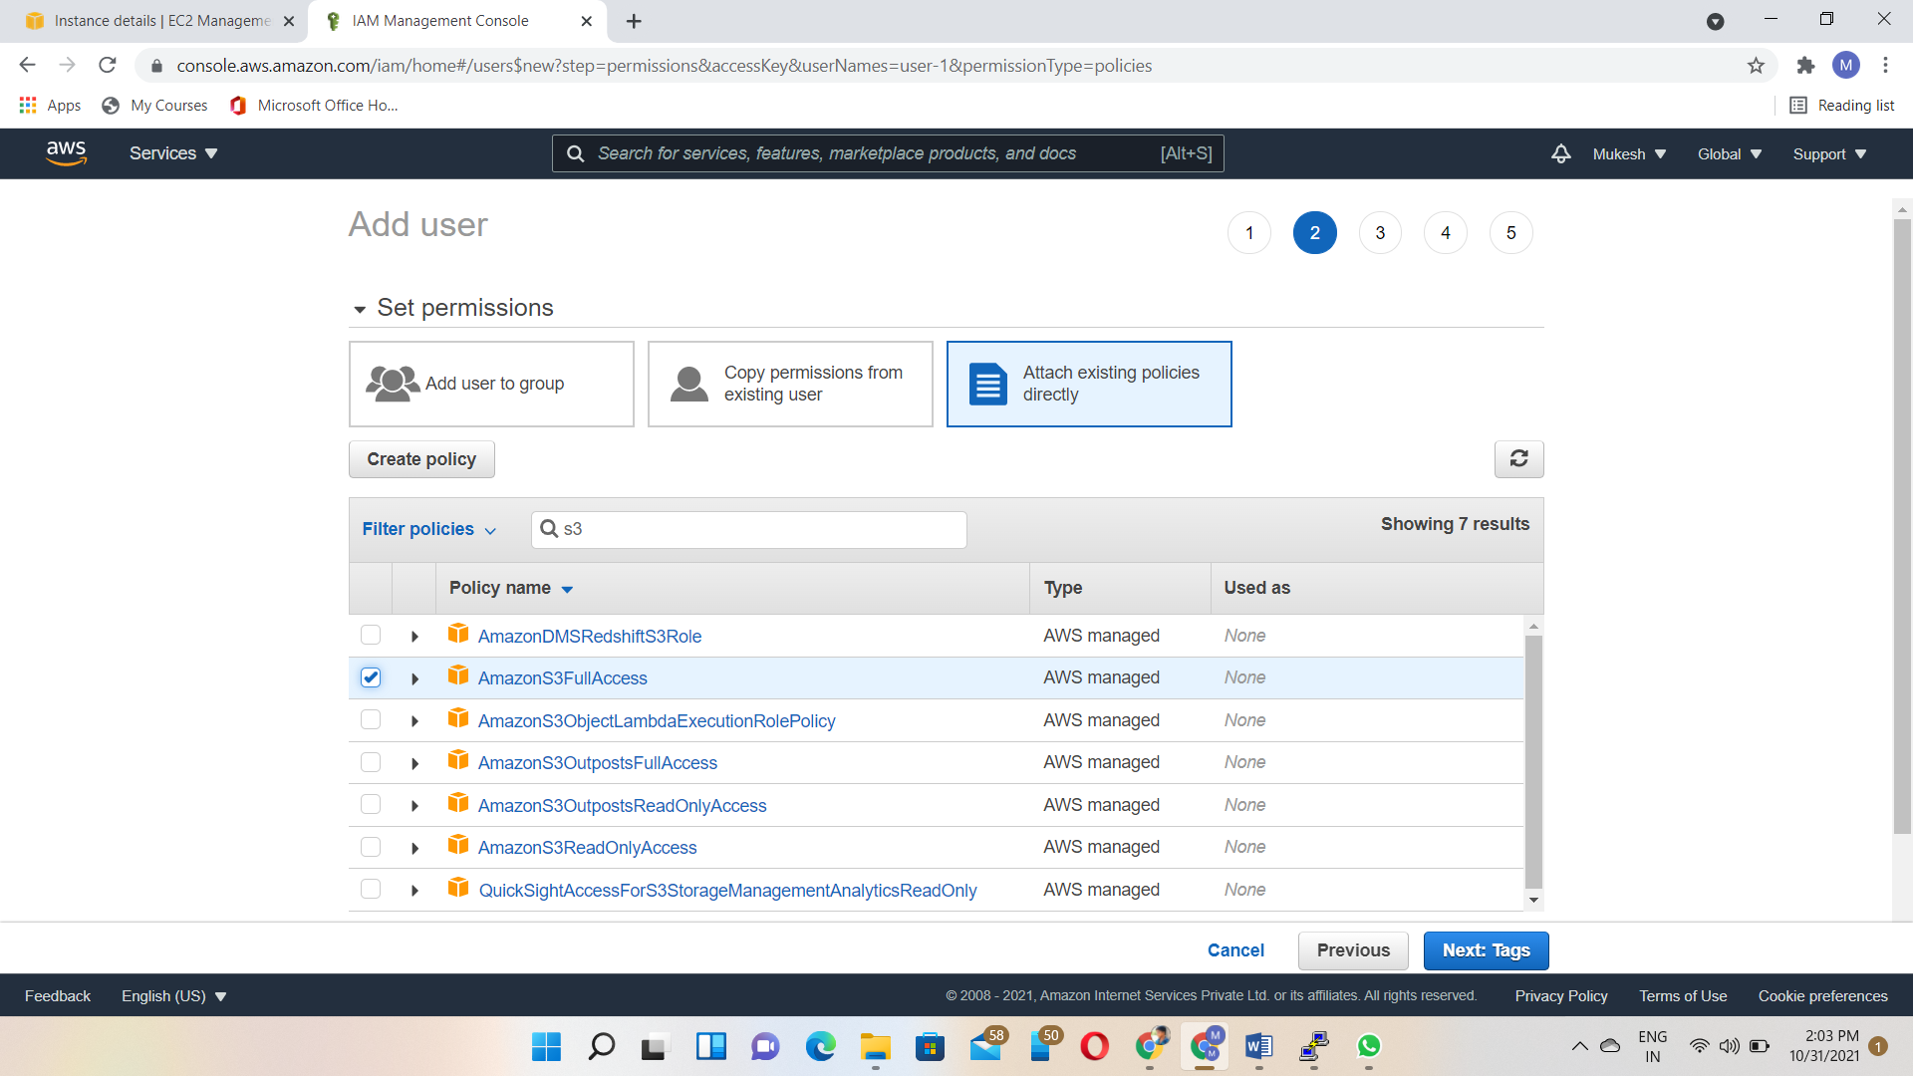

IAM User created

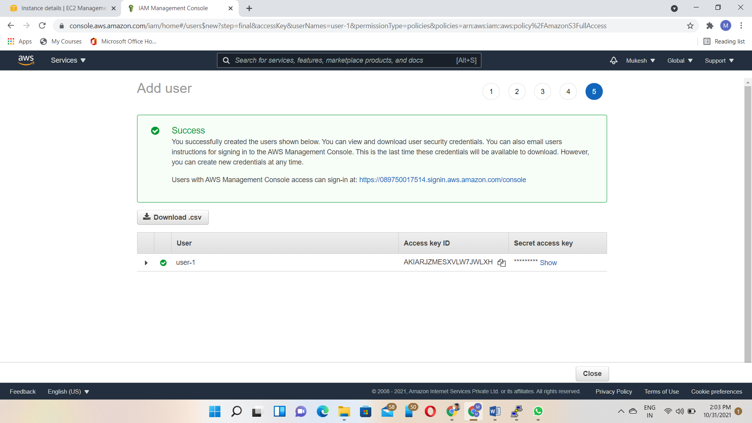

Vim .password - To create and save the hidden file with access key and secret key

Copy & paste the access key & secret key to inside the .password file using vim editor

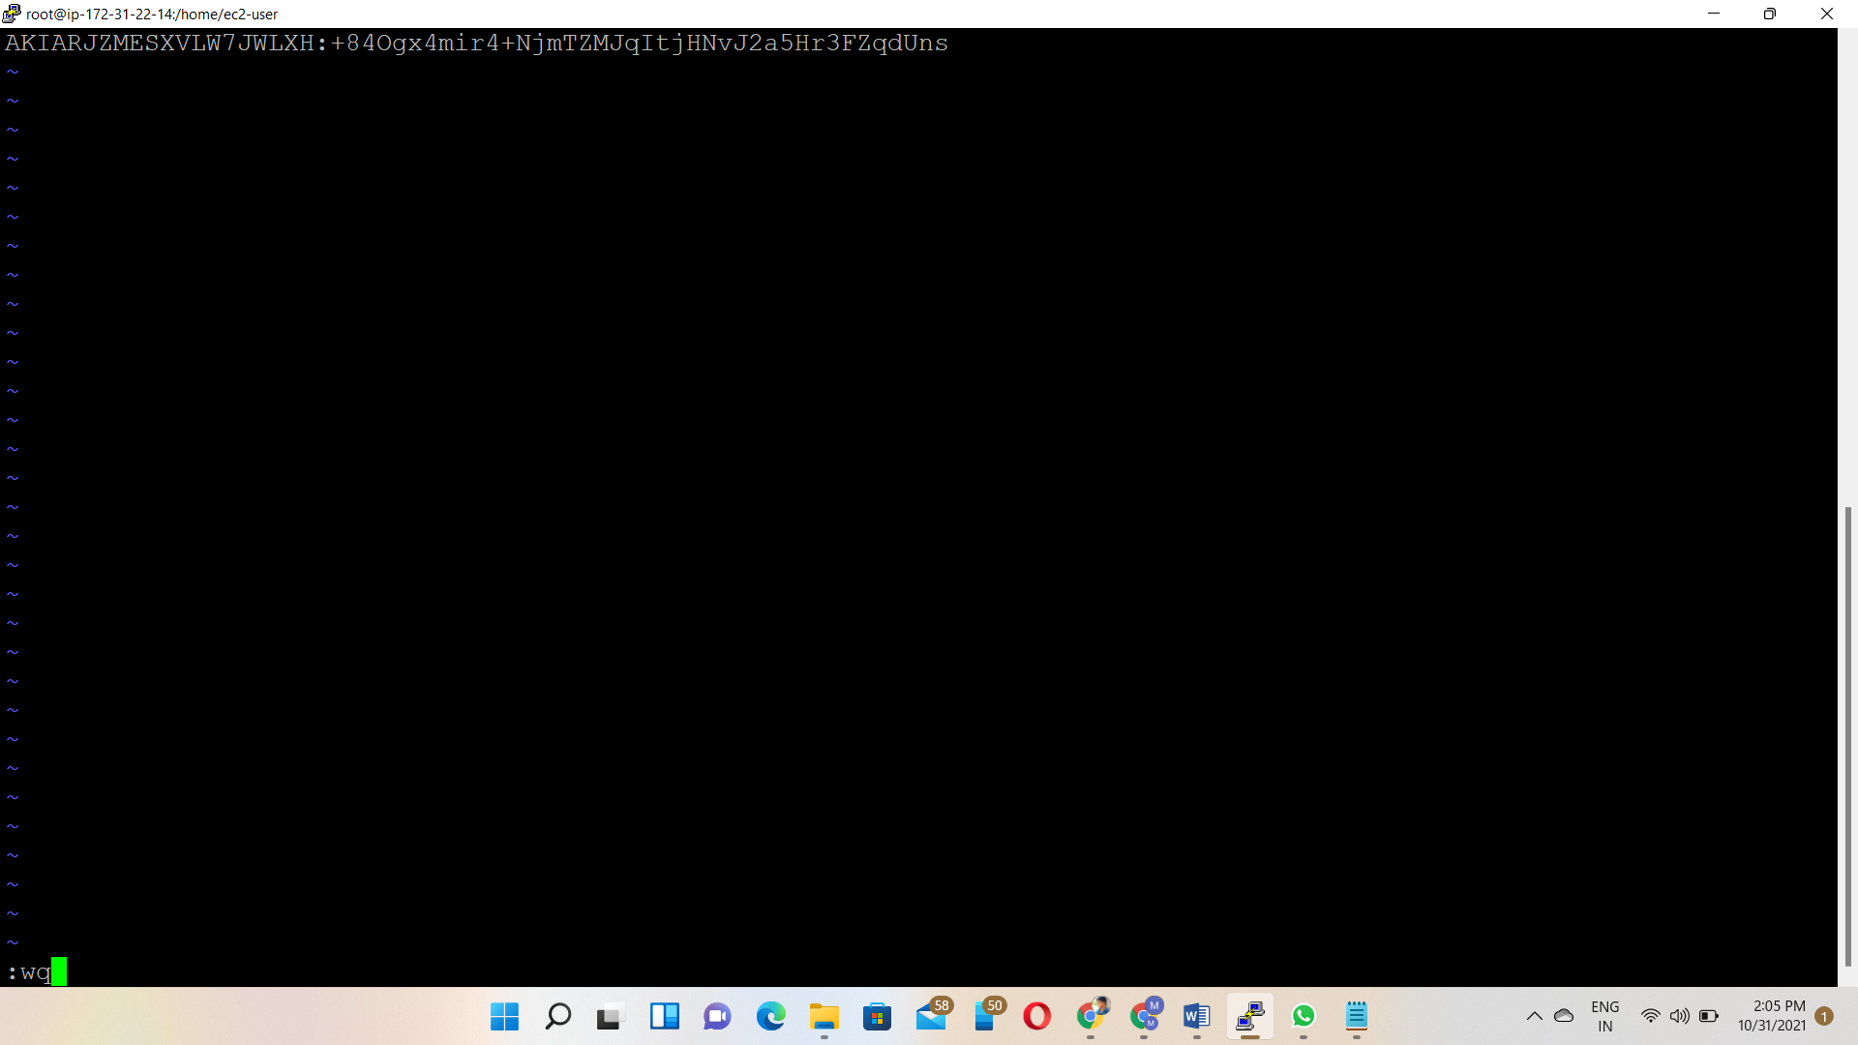

Chmod 600 .password - The chmod (short for change mode) command is used to manage file system access permissions on Linux and Unix-like systems

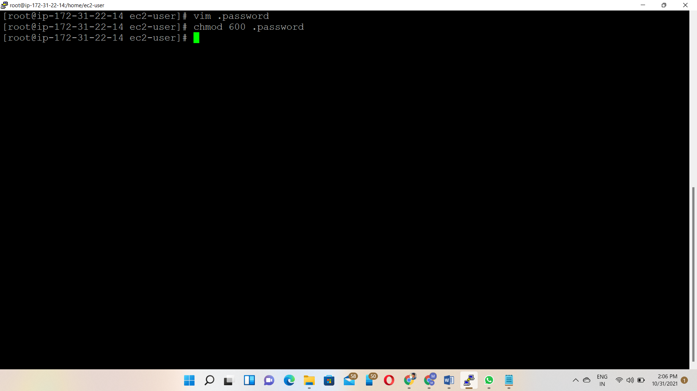

Go to s3 service and create one s3 bucket

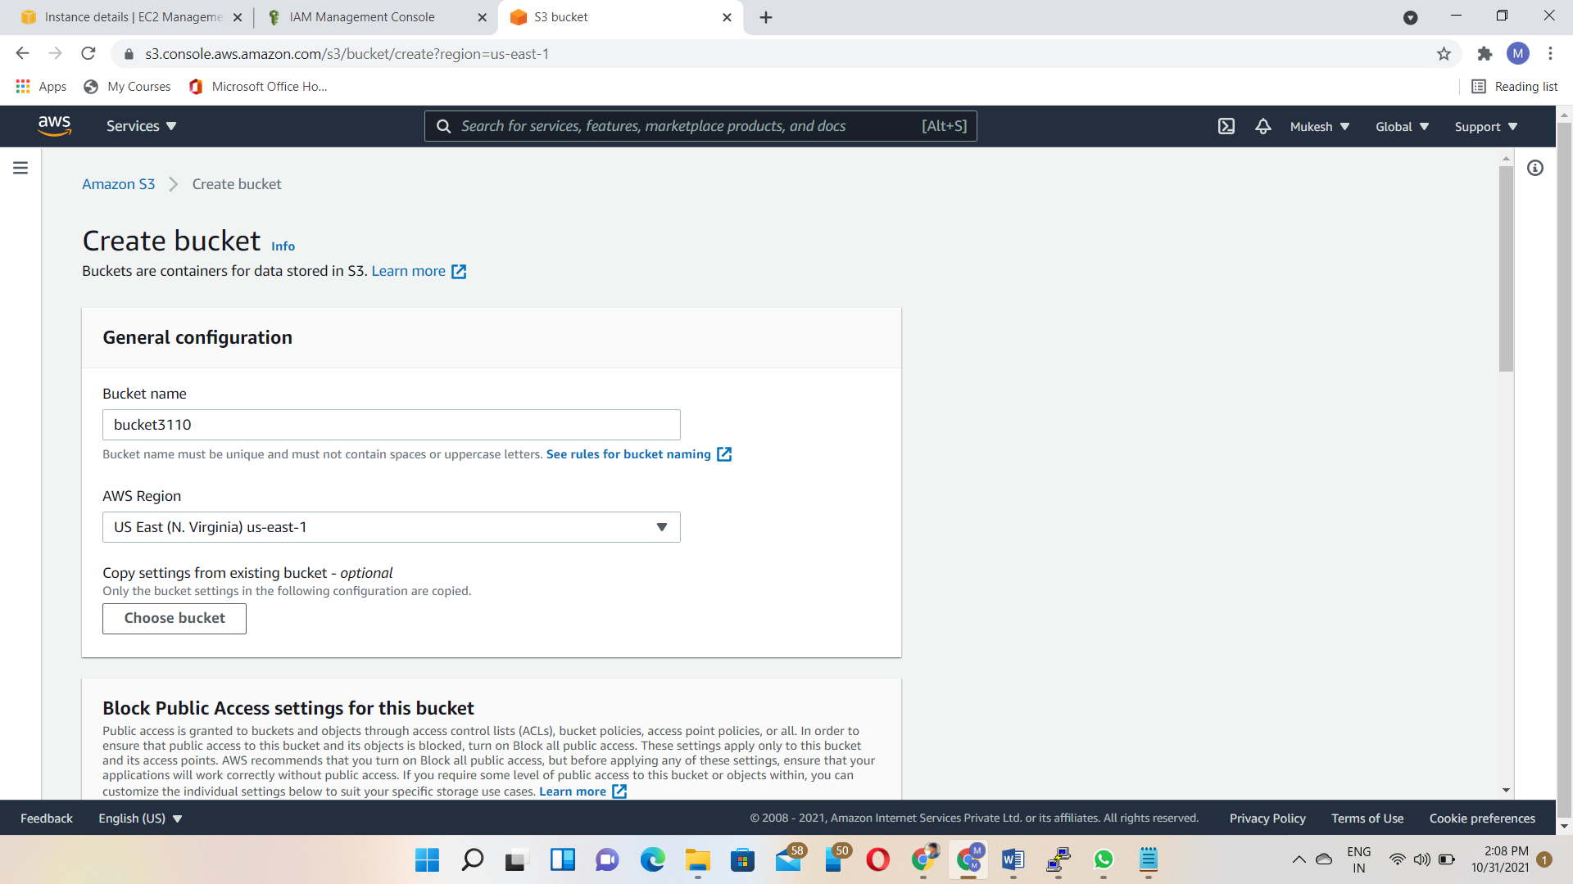

Any file uploaded inside the bucket

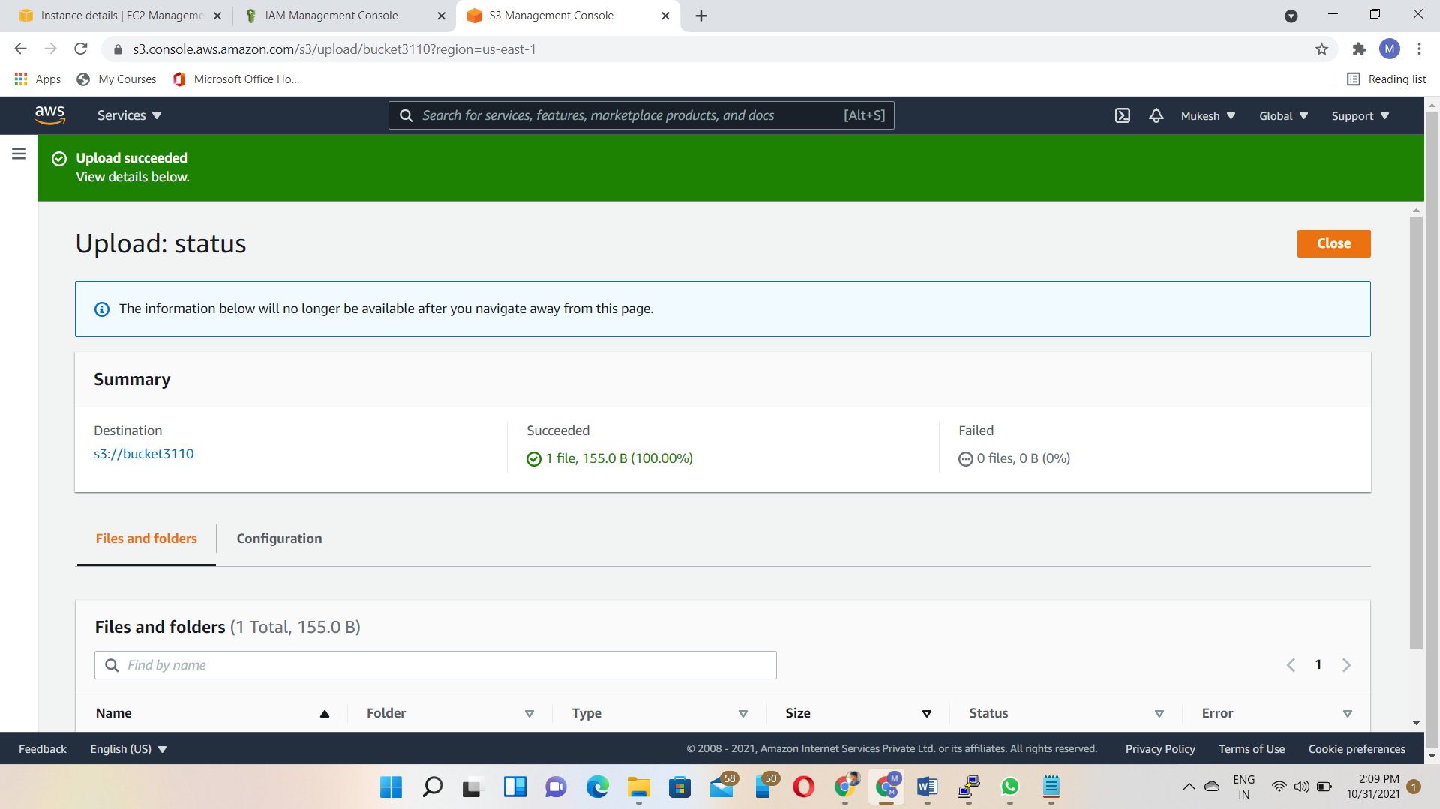

mkdir 🡪 Make a directory

S3 bucket mounting command🡪S3fs bucket name username password

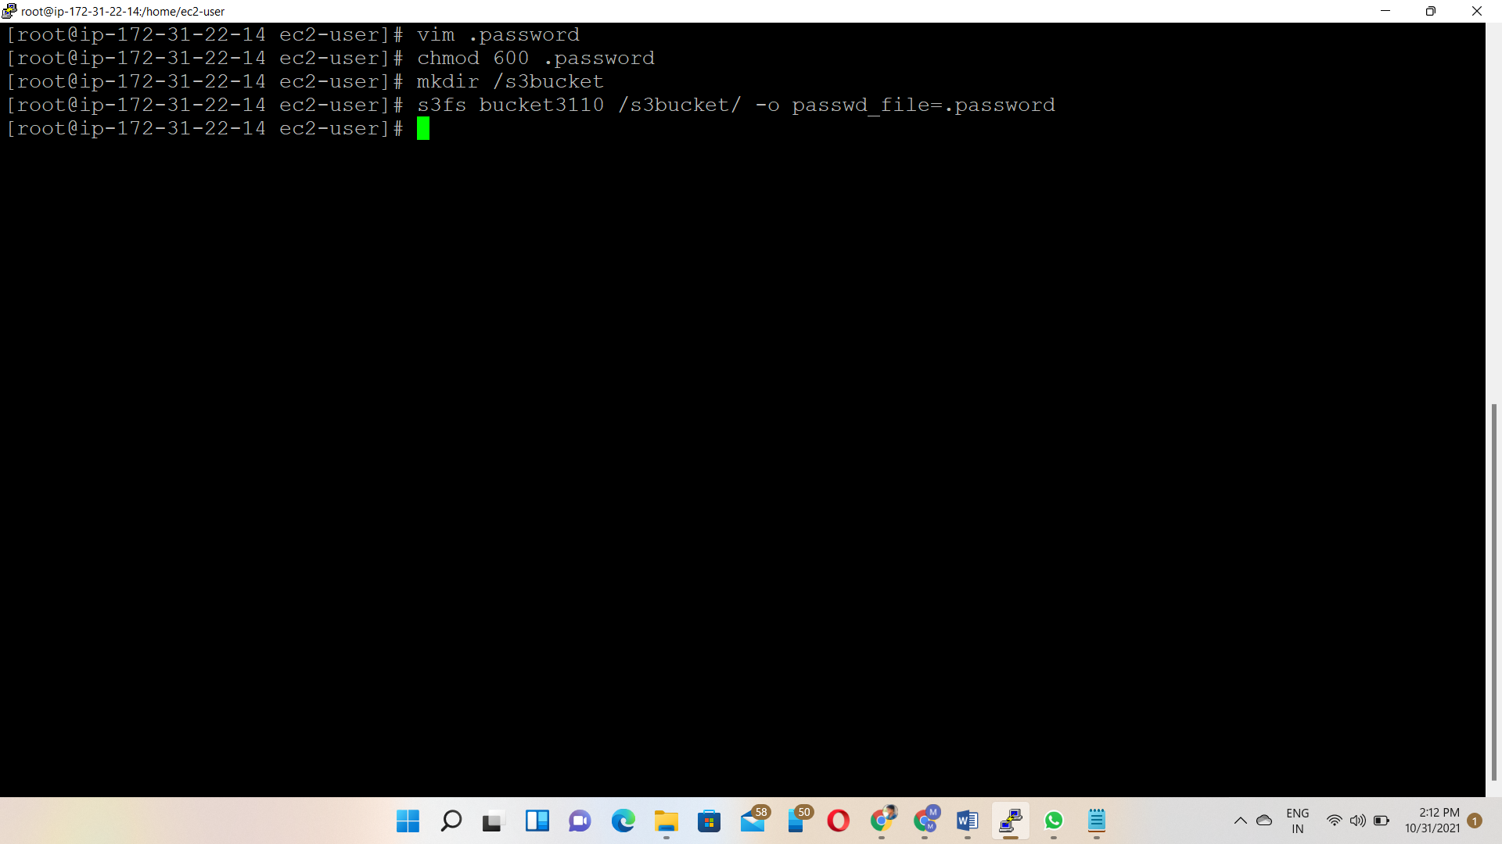

Df –h🡪 To check the s3 bucket mounting or not

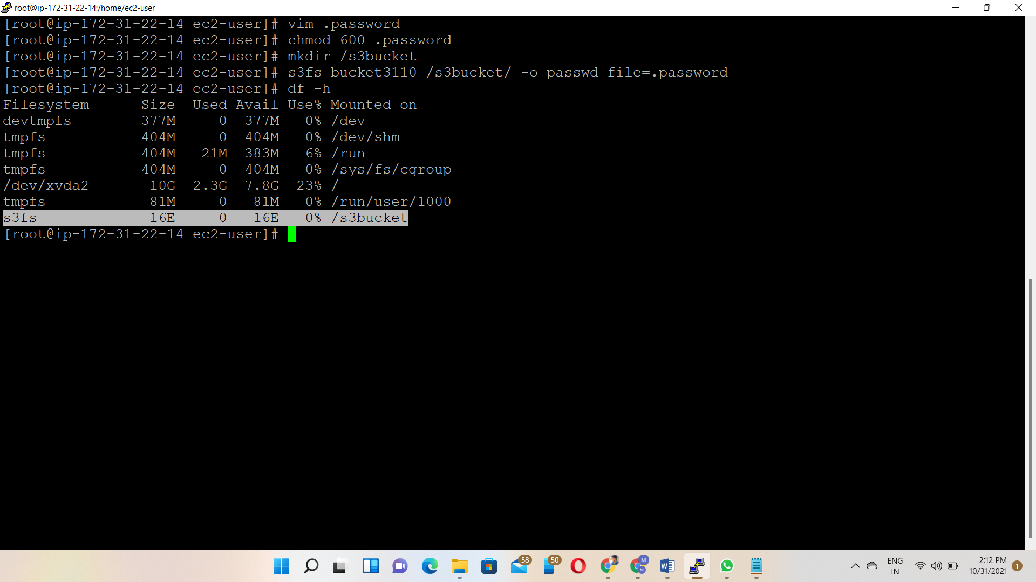

Output🡪 S3 bucket access through the Ec2 instance

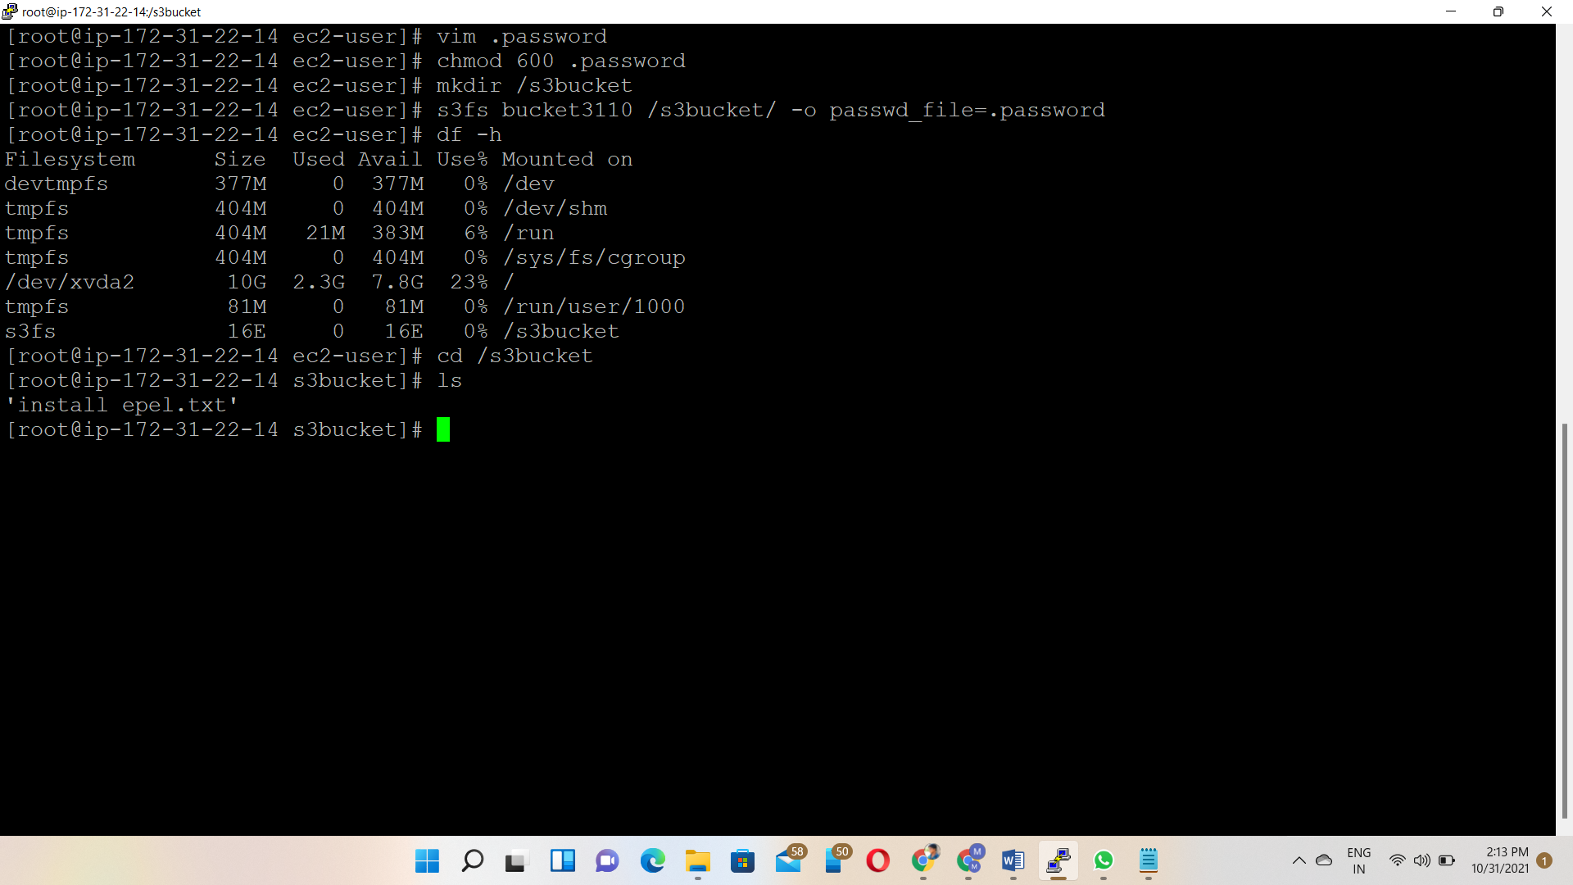

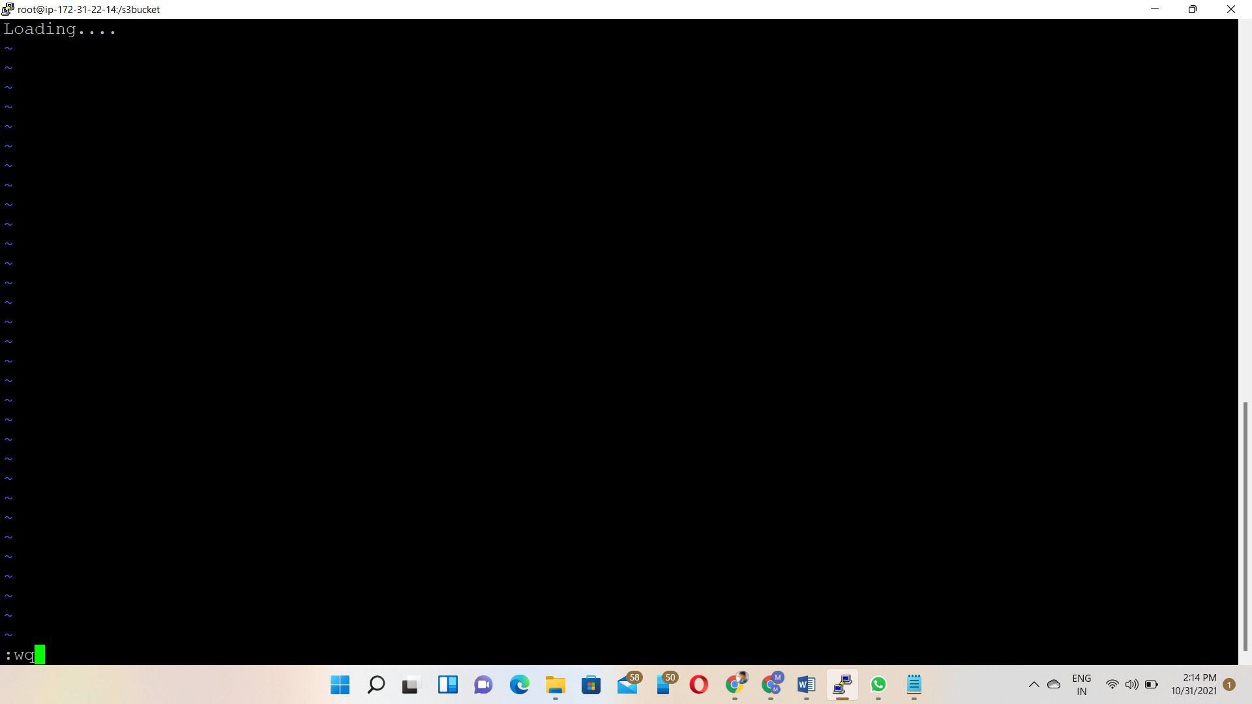

What file we created in the Ec2 instance that may upload in the S3 bucket

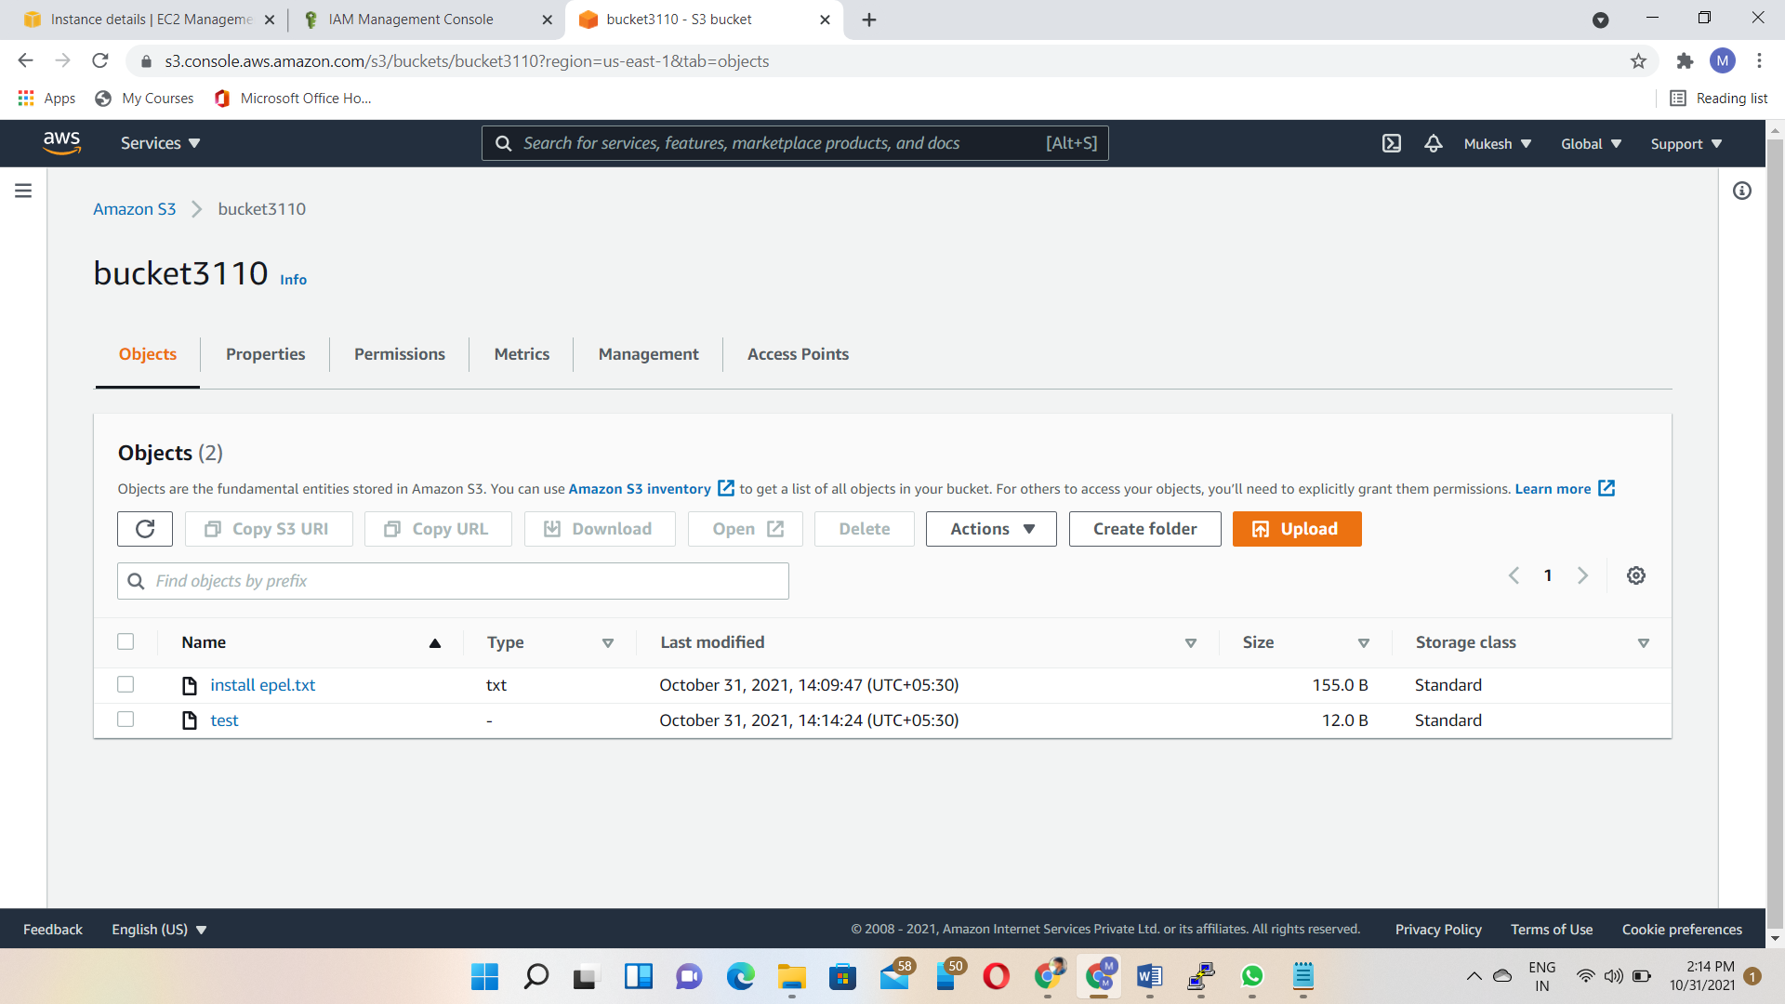

**History of command**

